DBMS

LAB ASSIGNMENT - 1



Ananya Agarwal

102083036

2CO14

1. Create table Student (Rno, Name, DOB, Gender, Class, College, City, Marks)

create table Student(Rno number, Name varchar2(20), DOB date, Gender varchar2(7), Class number, College varchar2(30), City varchar2(20), Marks float)

E:\4th sem\DBMS\lab\ass\1.PNG

1. Insert 5 records in student table

insert into Student values(1,'Ananya',to\_date('12/03/1993','DD/MM/YYYY'),'Female',11,'TIET','Patiala',100);

E:\4th sem\DBMS\lab\ass\2_1.PNG

insert into Student values(3,'Sham',to\_date('1/03/1994','DD/MM/YYYY'),'Male',12,'MIT','Amritsar',55);

E:\4th sem\DBMS\lab\ass\2_1.PNG

insert into Student values(9,'Sita',to\_date('2/01/1992','DD/MM/YYYY'),'Female',10,'IIT','Delhi',40);

E:\4th sem\DBMS\lab\ass\2_1.PNG

insert into Student values(4,'Gita',to\_date('16/04/1993','DD/MM/YYYY'),'Female',12,'NIT','Surat',21);

E:\4th sem\DBMS\lab\ass\2_1.PNG

insert into Student values(5,'Rahul',to\_date('1/05/1997','DD/MM/YYYY'),'Male',9,'PU','Punjab',27);

E:\4th sem\DBMS\lab\ass\2_1.PNG

1. Display the information of all the students

select \* from Student

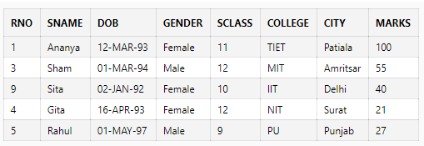

1. Display the detail structure of student table

describe Student

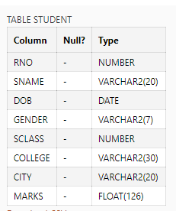

1. Display Rno, Name and Class information of ‘Patiala’ students.

select Rno,Name,Class from Student where City='Patiala'

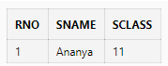

1. Display information on ascending order of marks

select \* from Student order by Marks

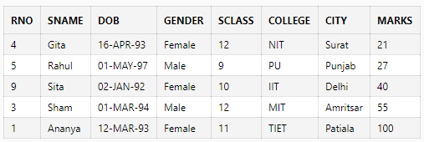

1. Change the marks of Rno 5 to 89.

update Student set Marks=89 where Rno=5

E:\4th sem\DBMS\lab\ass\7.PNG

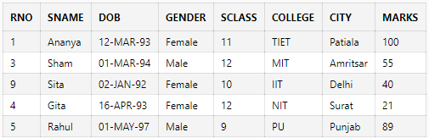

1. Change the name and city of Rno 9.

update Student set Name='Pooja', City='Barielly' where Rno=9

E:\4th sem\DBMS\lab\ass\9.PNG

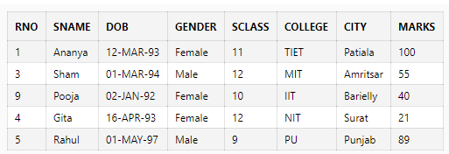

1. Delete the information of ‘Amritsar’ city records

delete from Student where city='Amritsar'

E:\4th sem\DBMS\lab\ass\12.PNG

1. Delete the records of student where marks<30.

delete from Student where Marks<30

E:\4th sem\DBMS\lab\ass\11.PNG

